**External Documentation**

**Name: Devam Shah**

**BannerID: B00845038**

**Overview –**

This program allows a user to create a crossword puzzle (according to rules), solve it and print to output screen.

**Input Style –**

A user can provide a puzzle in a file.

loadpuzzle(stream) – Uses object of BuffereReader to read input from a file.

solve() – Solves the function.

print(outstream) – Uses object of PrintWriter class , to print the solution to output screen.

choices() – Counts the number of undo operation the program has done to solve the crossword.

Sample sequence of input commands can be –

FillInPuzzle F = new FillInPuzzle();

F.loadpuzzle(“first.txt”);

F.solve();

F.print(outstream);

int choice = F.choices();

System.out.println(choice)

**Output –**

* Prints the loaded puzzle
* Prints the solved crossword

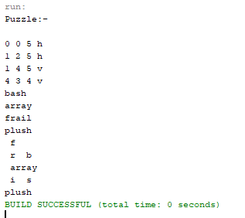

**Understanding Code / Code Explanation**

**The logic is based on recursion and backtracking**.

The program will find the solution least possible changes or undo moves.

Lets take the same example provided in the question.

Value-List is {bash,array,frail,plush}

The program will start with checking the length of slot and word (bash in this case).

If it is not equal then it will take the next iteration (array). Now array will be pass the checking condition of length and will be placed on board (Conflicts will be checked for further iterations , however in this case the board is empty). Since array is placed on crossboard, we will remove it from the value list and call recursion again.

Value-list is {bash,frail,plush}

Similar process happens and frail will be inserted on the board on the next slot. We will remove frail from value-list.

Value-List is {bash,plush}

Now, during this recursion, plush will be “Conflicted” and we will check the next word. If no words match the next slot, then we revert back (backtrack) to previous slot and try new word in that. (NOTE – It is important to undo all the changes that was made i.e removing of slot details and setting crossboard back to its previous state).

Value-List is {frail,bash,plush} // Add the word “frail” back to value-list (because recursion failed) NOTE – Slot related data should be added back as well.

Since none of the words were able to find solution, we change the first word “array” to “frail” and the process repeats.

This way algorithm continues till a solution is reached. Program exits when the information list (slot-list) is empty.

**Data Strucutre –**

ArrayList – It is a resizable array, which can be found on java.util package.

Syntax **-** ArrayList<E> name = new ArrayList<E>();

**Coding Conventions –**

Method() – follows lowerCamelCase

Package() – follows lowercase.

Constant – Must be Uppercase eg – RED

Class – Written in UpperCamelCase

Parameter – follows lowerCamelCase

Local variable – follows lowerCamelCase

**References –**

* Stack Overflow
* GeekforGeeks
* Google Github – For Naming conventions

**Personal Information –**

Name – Devam Shah

E-mail – [devam.shah281997@gmail.com](mailto:devam.shah281997@gmail.com)

Mobile - +1 (902)9894511